6A^{th} Grade: Unit 7, Lesson 6

- Decompose the composite figure into triangles and rectangles.
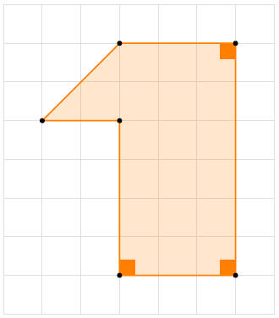

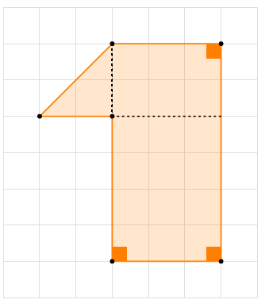
- What is the area of the rectangle shown?
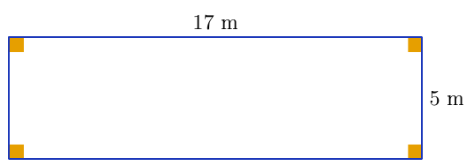
85 square meters

- What is the area of the triangle shown?
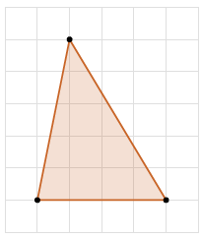
10 square centimeters
- The triangle shown has an area of 15 square inches. What is the missing dimension, k, in inches?
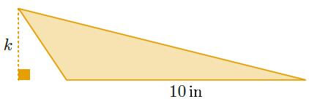

3

- What is the value of the expression $4÷1\frac{2}{3}$?

$$2\frac{2}{5}$$

- The rectangle shown has an area of 90 cm². What is the missing dimension, a?
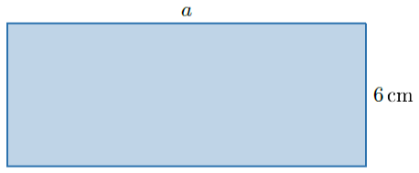
15 cm

